Scenario 1

1. It is required because it is used to identify / specify the Specific Condition whose attachments are to be retrieved.
2. its GET method is implemented in example. Also its response is an array of model-attachment-response
3. Only 200 OK / Sucess is implemented in API  
     
   - JSON based response  
   - Have array of model-attachments  
     
     
    but following can also be implemented to make better experience  
   1. 401 Unauthorized: The client is not authenticated or does not have the necessary permissions to access the endpoint.
   2. 403 Forbidden: The client is authenticated but does not have the necessary permissions to access the endpoint.
   3. 404 Not Found: The specified Specific Condition or attachment does not exist.
   4. 500 Internal Server Error: An unexpected error occurred on the server.
4. The model-attachment-response schema defines the structure of the response object that is returned by the API. he model-attachment-response schema is used to ensure that the API response is consistent and predictable. It also makes it easier for developers to consume the API and parse the response data.

It contains the following fields:

* 1. specific-condition-key: The unique identifier of the Specific Condition.
  2. attachment-name: The unique name of the attachment.
  3. attachment-URL: The URL to download the attachment.

1. If attachment-name parameter is not provided then it will show all attachments, that parameter is to specify the attachments by name.
2. Here are guidelines about security <https://swagger.io/docs/specification/authentication/> JWT here implies that the endpoint is protected by JSON Web Tokens (JWTs). This means that the client must provide a valid JWT in the Authorization header of the request in order to access the endpoint.
3. Here is example considering the parameter mentioned in query as per guidelines  
     
   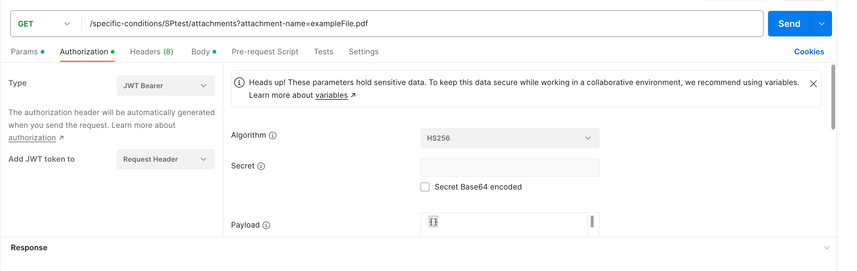  
     
     
   Its 2nd version could also be as follows if we consider the name is mentioned in URI  
     
     
   